The following are the final set of variables in the workspace at the end of running the ROIZER.m script…

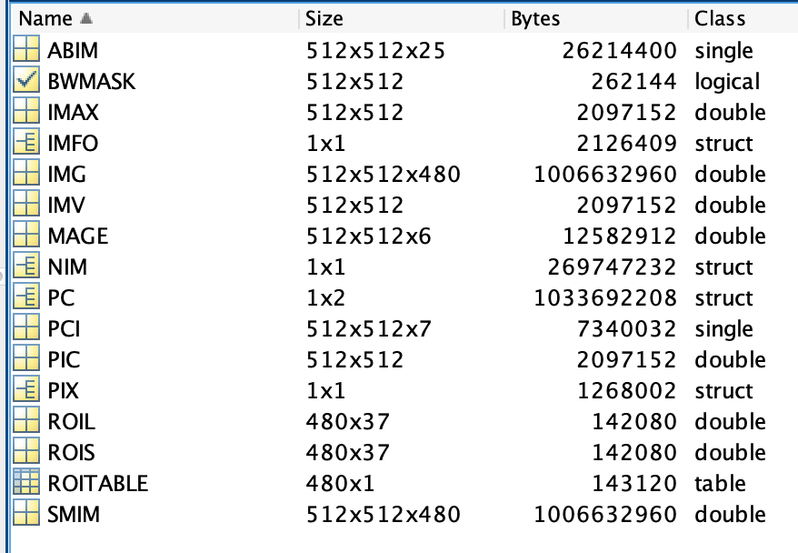

In the order they are generated in the script…

PIX

metadata about the imported tiff file

IMG

the tiff stack (an 3-dim rectangular double-precision matrix)

PC

principal component scores and coefficients

ABIM

absolute value after mean deviation of the first 25 principal component images

PCI

hand-chosen set of principal component images

IMAX

max pixel – min pixel value, every 20 frames, then average over all those max-mins.

IMV

standard deviation, every 20 frames, then average of the sd for the stack

use imstats() to get statistics for any of the above variables…

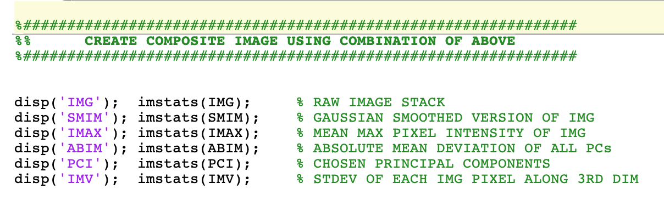

MAGE

A stack of each image transformation above to be used to perform image segmentations

PIC

an average of the images in MAGE

BWMASK

image mask the same size as the first image of the tiff stack, where each ROI have pixels represented by 1s while the rest of the pixels are assigned 0s.

IMFO

contains a number of useful ROI stats and masks…

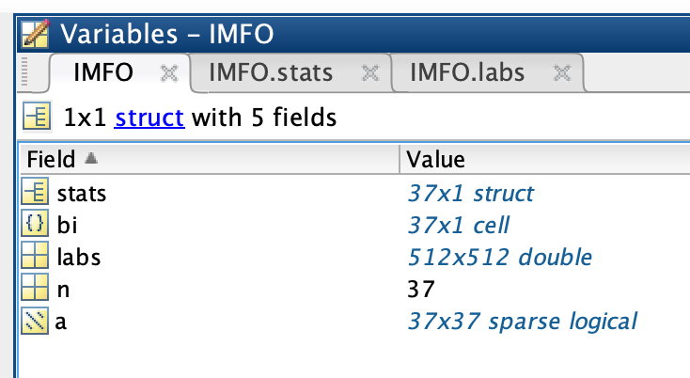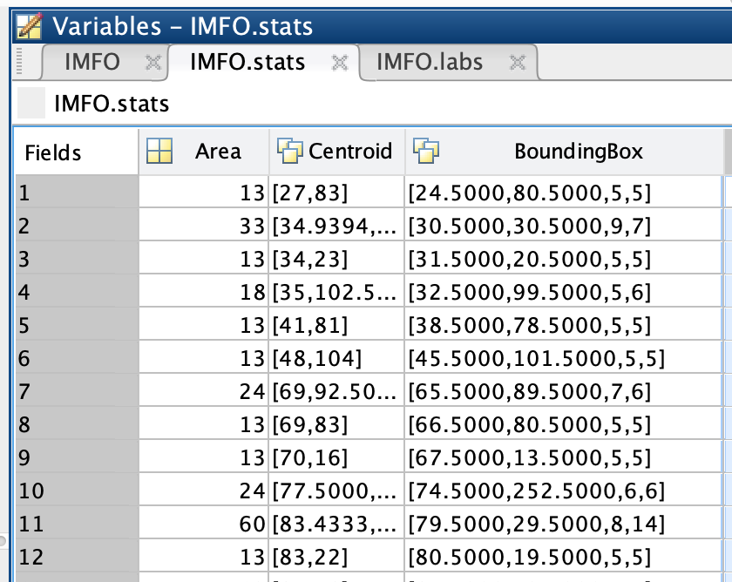

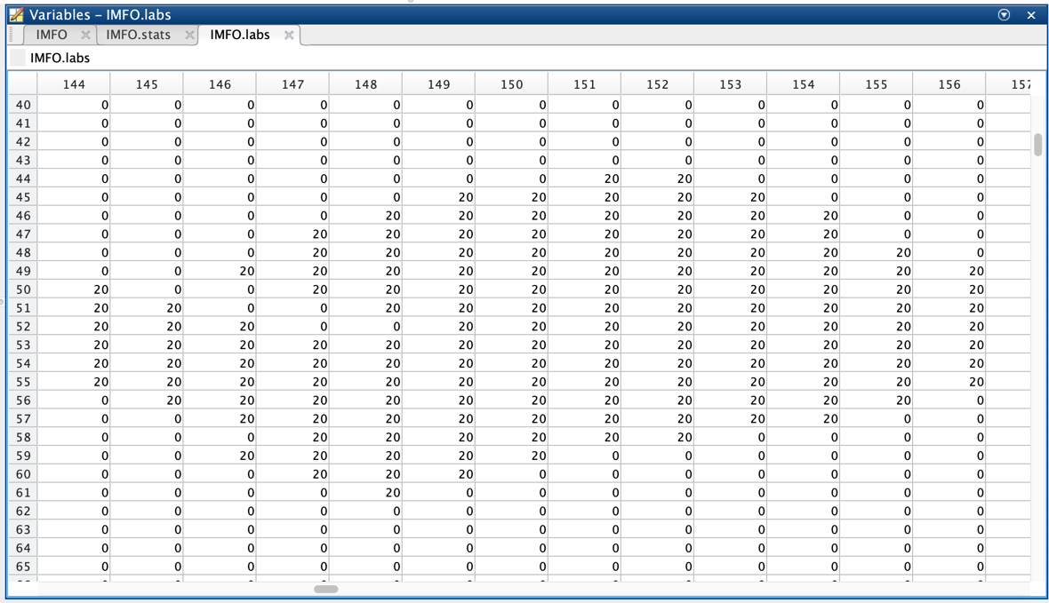

ROIS ROIL ROITABLE

The mean pixel value for each segmented ROI for each image in the stack